**Experiment 38**

**AIM :**

To design TM for wcw in automata.

**Design and output:**

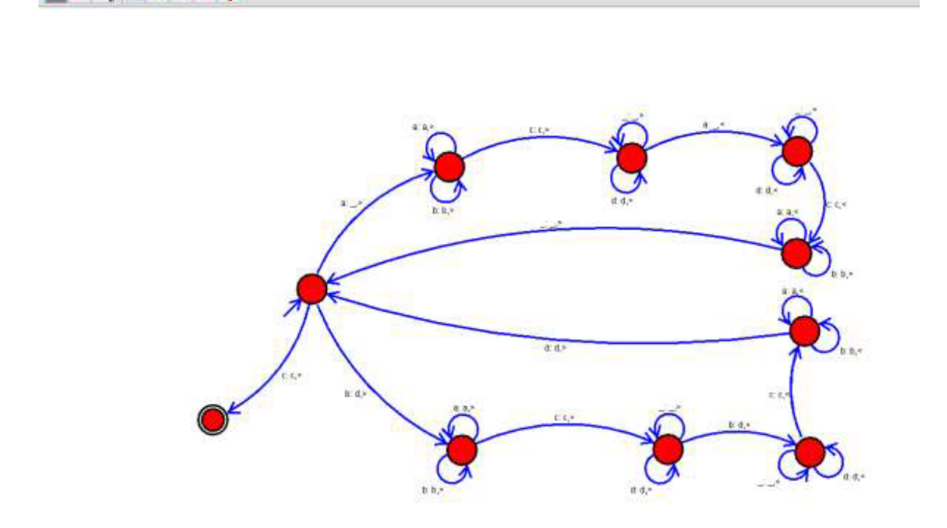

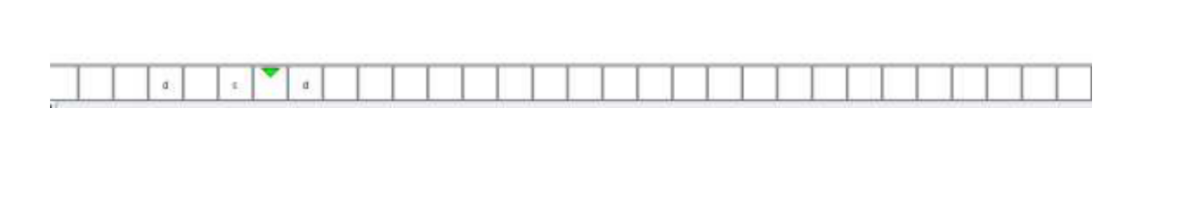

**Result:** Thus designing TM of WCW is done and verified by giving sample inputs.